Priority queues

Variant of sorting that generalizes the idea to provide a more flexible data structure that can be used for other applications

Priority queues remove the largest/ smallest item.

Priority queue looks similar to stack/ queue API, though we need to use generic items that are comparable. SEE: <Key extends Comparable<Key>> (the key must be Comparable)

.

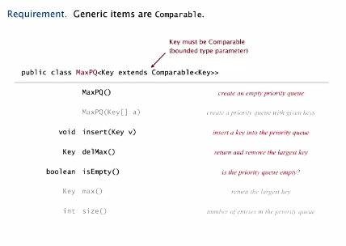

Many applications for priority queues:

* Event-driven simulation (customers in a line, colliding particles)’
* Etc.

Priority queue implementation with unordered array

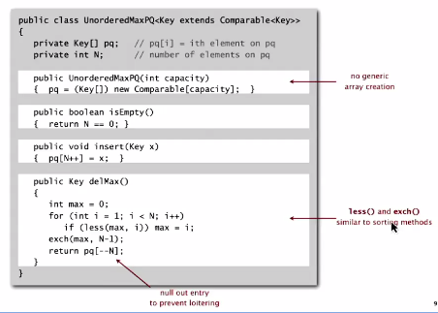

Running time for priority queue with ordered and unordered arrays respectively

